Ravage Stryczny

Fones School of Dental Hygiene, University of Bridgeport

DHYG-513 Seminar in Contemporary Dental Hygiene Issues

Professor Jody-Bishop Pullon

March 12, 2021

**Oral Health Program for the Underserved, Lower Socioeconomic Adult Population that Visits the Emergency Departments for Dental Pain in Manatee County, Florida**

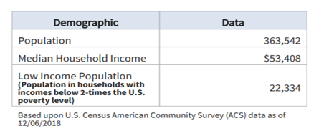

**Introduction**

The Healthy People reports issued by the Surgeon General initially began in year 2000 and its mission is “to promote, strengthen, and evaluate the nation’s efforts to improve the health and well-being of all people” (U.S. Department of Health and Human Services, n.d., para. 3). This country is facing a dental health crisis -- a gap between those with good dental health and those without.

The FDI World Dental Federation declared that good oral health care is a basic human right. Yet, the people who need oral care the most are, remarkably, the least likely to receive it. The number of dental visits to hospital emergency departments (ED) doubled from 1.1 million in 2000 to 2.1 million in 2010 (while total population increased 9.7%), according to the Healthcare Cost and Utilization Project (ADA, 2014). People suffering from dental pain need somewhere to turn for help, though many people assume that the ED is the only place in their community where they can seek dental care (ADA, 2014).

EDs are inundated in Manatee County with patients seeking treatment for dental pain (see Tables 1-3) and they are under-equipped and not sufficiently staffed to provide comprehensive dental care. In addition to taxing the department's overall resources, these patients are not receiving the comprehensive dental care needed to address their problems (ADA, 2014). Many patients are only prescribed antibiotics and pain medication; however, the underlying dental problem is not addressed, causing the problem to worsen and the patient to return to the ED (ADA, 2014). Providing temporary relief helps, but toothaches, like most problems, don’t fix themselves.

The number of dental-related visits to Florida EDs by persons aged 25-34 years comprised a larger proportion of visits than any other age group, accounting for about one-third (34.9%) and about three-quarters of visits were by individuals covered by Medicaid (39.0%) or self-pay (35.6%) (Tomar, S. & Carden, D, 2016).Total charges for dental-related ED visits in Florida increased about four-fold from $47.7 million in 2005 to $234.4 million in 2014 (Tomar, S. & Carden, D, 2016). There are more than 2 million visits every year to hospital emergency rooms for dental pain – these ED visits can be referred to hospital dental clinics, potentially saving the healthcare system $1.7 billion and getting people the right kind of care they need now (Feinberg, 2014).

Acute pain and infection lead individuals to seek care at one of the few facilities accessible to them: the local hospital ED. The utilization of EDs for dental conditions burdens the hospital, drains resources and becomes a cycle of care that does not treat and solve the underlying patient problem. A major driver of dental-related ED visits is a failure to ensure that disadvantaged people have access to routine preventive and restorative care. The reliance on ED dental treatment is symptomatic of a larger problem: A public that is alarmingly uneducated about the severe consequences of inadequate dental care and system that refuses to acknowledge oral health as a crucial aspect of overall medical health.

Access to dental services is a challenge in Florida and include the following barriers to care: affordability, geographic location, poor oral care literacy/language barrier, low priority of dental public health , lack of awareness of the need for care, fear of dental procedures, lower levels of education and income, mal-distribution of dentists, and lack of dentist participation on Medicaid. Florida is one of the most ethnically and racially diverse states, with Hispanics/Latinos, African Americans, and Asians comprising of about 44% of Florida’s population (21.73 million, 2020) (census.gov). An estimated 16.3% of Florida residents live below the federal poverty level (healthcare.gov).

The state’s Medicaid model is problematic. Florida’s Medicaid program provides only emergency services. Florida has one of the nation’s lowest Medicaid reimbursement rates relative to private fees; the fee-for-service rate in 2014 was 36.6% of commercial insurance charges in the state, ranking Florida as 43rd among the 50 states (Tomar, S. & Carden, D, 2016). The state’s Medicaid dental program has the nation’s lowest rate of dentist participation and as of December 31, 2020, Florida had 259 dental care health professional shortage areas. This is by far the greatest projected shortfall of dentists among the states (Tomar, S. & Carden, D, 2016).

**Table 1**

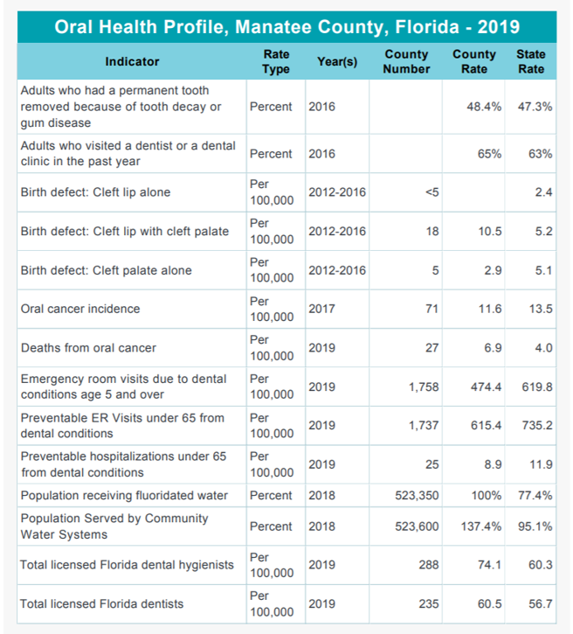

**Table 2**

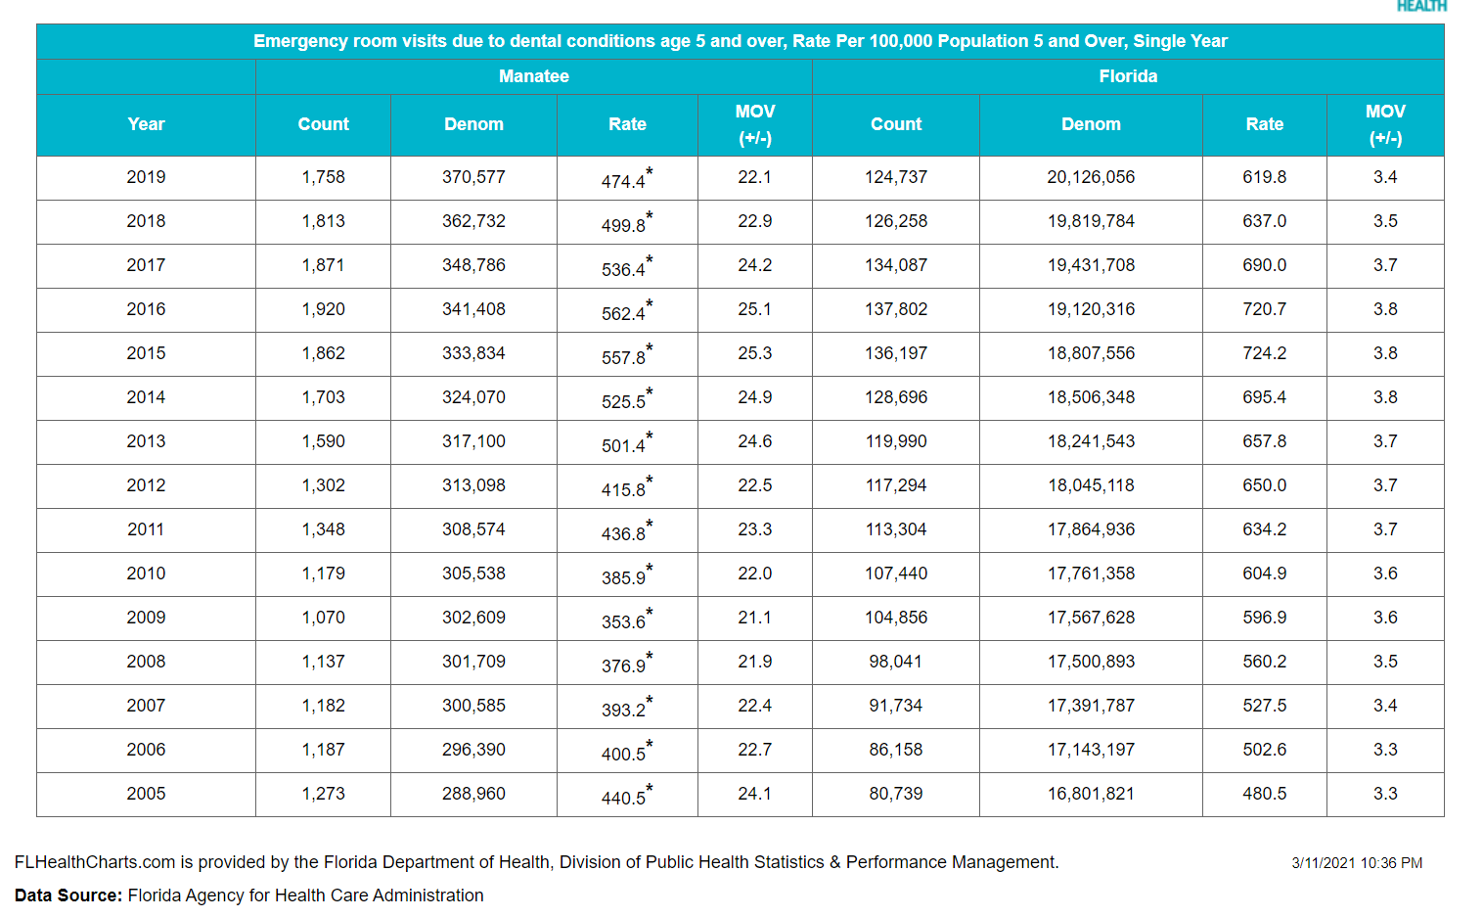

**Table 3**

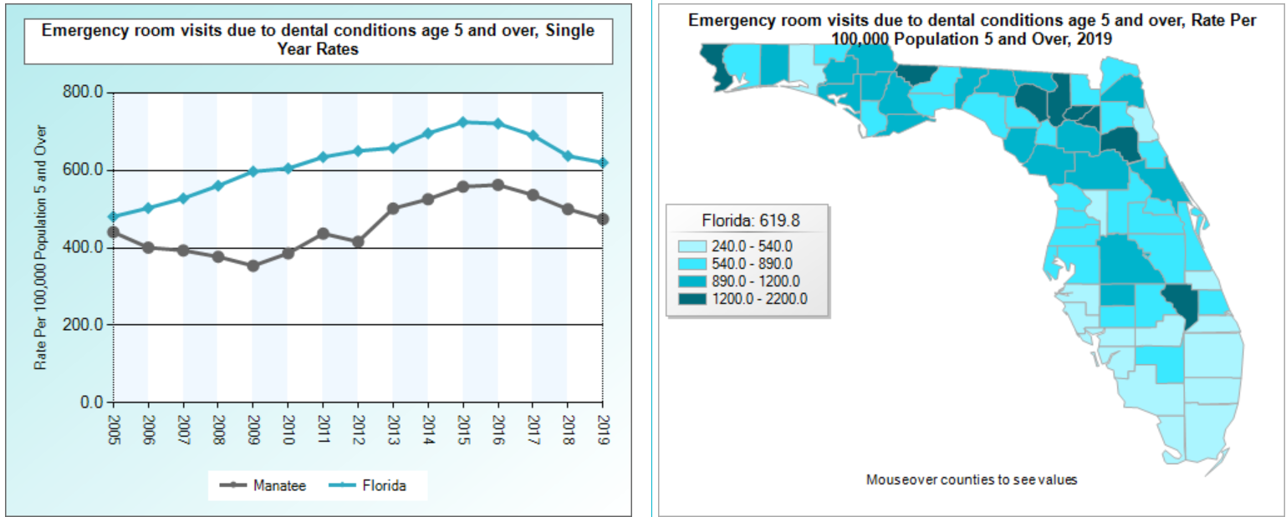

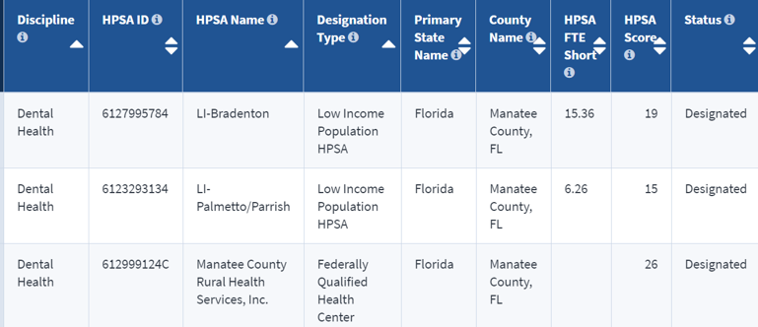

**Goals and Objectives**

Goal: To build and staff two hospital dental clinics inside Manatee County Hospitals to reduce health care costs and improve patient care.

1.1 Objective: Within six months secure funding for the dental clinics, build community partnerships and launch social media campaigns that focus on the new hospital dental clinics that are available for the underserved, lower socioeconomic adults in Manatee County, Florida.

1.2 Objective: By the end of the program, increase the proportion of adults in Manatee County, Florida who receive preventive interventions and oral health care education by 75%.

1.3 Objective: By the end of the program, improve access to dental care for underserved, low socioeconomic adults in Manatee County by 50%.

Goal: To reduce ED dependency for the underserved, lower socioeconomic adults with dental caries and the pain associated with dental emergencies in Manatee County, Florida.

1.1 Objective: By the end of the program, adults with non-traumatic dental-related problems managed in the ED will be decreased by 50% in Manatee County, Florida.

1.2 Objective: By the end of the program, adult dental patients with repeat visits to the ED in Manatee County, Florida will decrease by 75%.

1.3 Objective: By the end of the program, the barriers to accessing dental care to the underserved, lower socioeconomic adult population in Manatee County, Florida will be reduced by 35%.

With bold goals and a commitment to join together locally and nationally, we can all but eliminate routine dental problems clogging ERs by providing the right care in the right place: the dental chair (Norman, 2014). Providing equal and fair oral care to people of diverse populations residing in communities and addressing oral health as a “public health issue” is a turn in the right direction (Albino et al., 2019, p. 45). My oral health care plan addresses ways to improve oral health within the low socioeconomic adult population in Manatee County, Florida by involving the individual, professional and community levels.

**Program Design**

The only way that I can see a positive impact and a substantial reduction in ED visits for adults with oral pain is to bring a solution directly to the communities where we live. The dental patients get the care they need, and the hospital is able to free up the ER staff to handle more urgent emergencies, saving time and money (Norman, 2014). Build two Hospital Dental Clinics located inside of the Manatee County hospitals staffed with employees and volunteers. Patients must be a resident of Manatee County to use the services and no one will be turned away because of the inability to pay. The program is a non-profit organization funded primarily through donations, grants and fundraising efforts. The clinics are on major Manatee County bus routes, making them more accessible for the safety-net population

If you doubt there’s a dental health crisis in America, walk into any ED. Every day, thousands of people without access to a dentist are looking for dental care in our EDs, most of which cannot provide the care these patients need (ADA, 2014). Those ED visits for largely preventable issues cost the health system more than $2 billion per year and the majority of dental ED visits, nearly 80%, were for common and preventable conditions like abscesses and cavities (ADA, 2014).

**Plan**

* Step 1: Identify the problem-Use of Hospital EDs in Manatee County, Florida for Dental Problems.
* Step 2: Develop a one-page fact sheet about the program in English and Spanish to distribute to any parties that could potentially be involved in the program. The justification for a simplified fact sheet about the program in multiple languages is to address the bilingual population and ensure that they understand the most important details of the program.
* Step 3: Create a manual and course for training in communication skills, empathy, cultural awareness, professionalism, emotional intelligence, and mindfulness. Cultural competence is the ability of providers and organizations to effectively deliver health care services that meet the social, cultural, and linguistic needs of all patients (Health Policy Institute, 2019). Individuals across the United States of various cultural backgrounds are limited in the attainment of their highest level of health for several reasons, including the social determinants of health, or those conditions in which individuals are born, grow, live, work, age, socioeconomic status, education level, and the availability of health services (Office of Minority Health U.S Department of Health and Human Services, 2013). The justification for the manual and training is that Cultural competence helps to decrease health inequities and the disparities that subsequently result.
* Step 4: Identify who else cares about the issue- Create social media marketing campaigns on LinkedIn, Facebook, Instagram, and Twitter with a call to action to see interest in volunteering for this program. One social media campaign will be developed to recruit bilingual healthcare professionals who wish to work in the dental clinics. Create a social marketing campaign for adults in Manatee County that have Medicaid or lack dental insurance coverage.
* Step 5: Personally contact community funders, not-for-profit organizations and local fraternal organizations to see what financial support they can provide including building the hospital dental clinics, providing funding for patients who can’t afford treatment, sponsorship and fundraisers. Reach out to dental manufacturers and dental dealers to see what they will donate to the clinics. Establish a meeting with the Department of Health regarding resources available and potential of establishing grants for hospital dental clinics.
* Step 6: Establish a meeting with organizations that support the expansion of all practice acts in dentistry to increase access to care. Justification-The ADHP has not been passed in Florida.
* Step 7: Contact local politicians/lobbyists, ER physicians and public health officials for assistance with passing the role of the Advanced Dental Therapist in Florida. Justification-Emergency room physicians would most likely support expansion of the scope of dental hygienists and mid-level providers because it would lead to less patients utilizing the ER for toothaches and infections; conditions that can be treated and prevented with routine dental care at a significantly lower cost (Potter, 2017, p. 26). From a financial standpoint, Potter (2017) stated the ADA estimated that by 2012, ER visits for dental related pain cost the U.S. healthcare system $1.6 billion annually; an average of $749 a visit (p. 26).
* Step 8: Contact LECOM and State College of Florida and meet with the administrators to establish relationships and sign contracts for the students to use these hospital dental clinics as their volunteer rotation sites. Justification-The exposure to this population is important when students are gaining their dental education so that they understand the need. If they are exposed prior to graduating they might commit to volunteering to help the underserved population after they graduate. The Commission on Dental Accreditation requires schools to ensure that dental students “have the interpersonal and communications skills to function successfully in a multicultural work environment” (CODA, 2010). In addition, the American Dental Education Association has established competencies for the new general dentist that include “applying appropriate interpersonal and communication skills, applying psychosocial and behavioral principles in patient-centered health care, and communicating effectively with individuals from diverse populations” (ADEA, 2009).
* Step 9: Contact hospital administrators at Manatee and Lakewood Ranch hospitals to have them send an email to all hospital staff members for participation in a virtual meeting to discuss the goals of the oral health program and the part that they can play in improving the oral health of the underserved population.
* Step 10: Establish a partnership with the local public health department to develop a curriculum with the Community Dental Health Coordinators which will provide 30-minute dental health education lessons via social media.
* Step 11: Invite everyone to a virtual meeting that are identified in Step 4-Step 10 that are interested in participating in the program to discuss details and expectations of the program.
* Step 12: Establish a contract with Uber and Lyft with negotiated transportation rates for patients to and from hospital dental clinics. Justification-this eliminates the barrier of care related to transportation.
* Step 13: Employ minorities at a minimum of 50% for the following per clinic:

Evidence regarding race- and ethnicity-based disparities in health status is mounting, and the need to increase diversity in the health workforce as a strategy for improving the nation's health is both logical and clear.

1. Four (4) Advanced Dental Hygiene Practitioners (ADHP)( legal)-Practice within the Scope of the DT (states that have passed the law). Justification- contributes to health policies that address disparities in oral health and access to care for the underserved and supports and applies health policy at the institutional, local, state, regional, and national levels. One ADHP will manage the program and be responsible for reviewing the analytics and putting policies in place for continuous improvement to meet the oral health needs of the underserved population. The ADHP will integrate practice management, finance principles, and health regulations to analyze, design and develop initiatives that will improve clinical outcomes, the quality of care and patient safety. Promote effective leadership for changing healthcare and practice environments. The ADHP would have a substantial impact on this population because a dentist does not need to see the patient prior to them receiving care or be on site during a procedure. This allows so many of the underserved population to be cared for immediately and eliminates treatment delays that could potentially become deadly.
2. One (1) Dentist –Provide comprehensive care that is out of the scope of practice of a Dental Therapist
3. One (1) bilingual Dental Assistant-Support the dentist with treatment
4. One (1) Oral Surgeon-Provide necessary extractions-Outsourced
5. Four (4) bilingual Community Dental Health Coordinators (CDHC)-Justification- Tens of millions of Americans lack adequate access to dental care.  Many of them suffer with untreated disease, and many more are at risk of disease. The CDHC’s will brings more people into the oral health system. Providing screenings, fluoride treatments, sealants, coronal polishing and radiographs for people of similar ethnic and cultural backgrounds. Collect information to assist dentists in triaging patients, address social, environmental, and health literacy issues, provide dental health education and help people develop goals to enhance their oral health, coordinate care in accordance with a dentist's instructions, and help patients navigate the complexities of the health care system. The CDHC) will be responsible for the coordination of referrals to make sure that the patient gets scheduled in the appropriate dental chair within a 24 hour period, unless the patient requires antibiotics. Each CDHC will be responsible for making sure that the patients gets antibiotics, if needed, in addition to making sure that the patients needing treatment do not get left behind. The CDHC is responsible for making the appointment and following through to make sure that the patient shows up for their appointment. A case worker/social worker will be assigned to each patient that enters the hospital dental clinic and if the patient does not show up for their appointment the case worker/social worker will need to find out why.
6. Two (2) Dental Hygienists- Justification-Provides preventive services and collaborates with social workers and CDHC’s to increase awareness about preventive oral health.
7. One (1) Safety Checker –Justification-improve quality of care and outcomes which will generate revenue rather than adding cost (financial equation that drives real change).
8. Two (2) Medical Interpreters – Justification-interprets and serves as patient navigators who help guide patients through the complexities of the health care system. Language concordance improves the patient satisfaction, engagement, perceived understanding and utilization of preventative services.
9. One (1) Social Worker/Case Manager –Justification- The National Assessment of Adult Literacy assessed the health literacy of adult Americans in 2003 on a large scale for the first time and determined that only 12 percent of adults had proficient health literacy (Kutner et al., 2006). One study that specifically investigated the oral health literacy of patients in a clinical setting found poor oral health literacy was strongly associated with self-reported poor oral health status and lower dental knowledge (Jones et al., 2007). Improving health literacy is just the beginning of the behavioral change process. Will work with the CDHC’s to guide improvements to the oral health of the population who will require behavior change at many levels (individual, families, communities). Educate patients about good oral health when they’re in the hospital dental clinics to make sure that they return for preventive and comprehensive care instead of just when they get another tooth ache. These patients require guidance, support and follow-up.
10. One (1) Hospitalist-Justification-these are the hospital physicians that will be utilized if patients have systemic links that need to be addressed. Referrals will be provided by the Dental Therapist or the Dentist. This position is outsourced.

* Step 14: Establish a relationship with Endodontists and Oral Surgeons (Outsourced) in the community for referrals. The Community Dental Health Coordinators (CDHC) would be responsible to provide the endodontist and oral surgeon diagnostically acceptable radiographs for the patients that need treatment. This would be completed through Tele-dentistry.
* Step 15: Schedule and train all staff members in a clinical setting focusing on their responsibilities.
* Step 16: Create a community-level social media campaign to educate Medicaid enrollees about the hospital dental clinics in Manatee County. Justification- Social media is one of the ways to get the information to this population.
* Step 17: Create a community-level campaign that is focused on health promotion and health education with calls to action (CTA). If there are requests from the CTA the CDHC will be responsible for responding to the requests. Track this information and run analytic reports.-Justification-It is important to reach people and social media is one of the ways to accomplish that. Running data reports t is the way to see if any changes need to be addressed.
* Step 18: Design a tracking system for the hospital ER and the two dental clinics so that data can be utilized to show the progress and challenges of the program.
* Step 19: Hire a company to build a website for the Hospital Dental Clinics. Justification- The website will link to the Hubspot social media platform.
* Step 20: Open the hospital dental clinics and begin to see patients. Justification-The ED should not be used for dental pain.
* Step 21: Implement the option for patients to send photos of their dental concerns over a secure network (HIPPA) compliant using teledentistry preceding an initial visit to the hospital dental clinic to increase care delivery, to overcome unanticipated barriers, and rapidly adapt to unforeseen situations. Teledentistry can enable early diagnosis, enhance the timeliness of treatment, and increase utilization of services and overall access to care ,and provides a method to initiate the establishment of a “dental home” for patients (Langelier M, Rodat C, Moore J. (2016). The dentist, LECOM resident and/or ADHP can review the photos and develop a plan. The patient would receive a call within two hours to schedule an appointment with the appropriate person in the clinic. If the patient needs an extraction or endodontic treatment they will be referred to the specialist.
* Step 22: After 30 days review the program and make any necessary changes that are needed. Justification-There are always kinks in a system and there is always room for improvement
* Step 23: After 60 days see if there are reduced ER visits for non-emergency dental pain by reviewing the data analytics from tracking system.

**Conclusion**

Researchers found that uninsured young adults, ages 19-34, and low-income residents have the highest number of ER visits for dental pain and infections that aren’t related to trauma (ADA, 2014). Preventative dental care is an investment against these costly emergencies and should be a simple solution. Dental Clinics within a hospital could provide care to low-income patients who have nowhere else to turn. With a bold oral health plan, we can all but eliminate routine dental problems clogging ERs by providing the right care in the right place: the dental chair. (ADA, 2014).

The underserved, low socioeconomic adults in Manatee County have nowhere to turn and it is our responsibility to provide care now to those suffering with untreated disease and find those who are delaying care and deliver it to them. This program will strengthen and expand the safety net to provide more care to underserved people and bring dental health education and disease prevention into Manatee County.

**References**

Albino, J., Dye, B., et al. (2020). 2020 Surgeon General’s Report – Oral Health in America: Advances and Challenges.

Bentley, C. (2018). Integrating Oral Health into Social Marketing Campaigns: Program Development and Description for San Francisco Children’s Oral Health Strategic Plan. Pacific Journal of Health. 1(2). pp.1-18.

Bouye, K. E., McCleary, K. J., & Williams, K. B. (2016). Increasing Diversity in the Health Professions: Reflections on Student Pipeline Programs. Journal of healthcare, science and the humanities, 6(1), 67–79.

Brian Z, and Weintraub JA. Oral Health and COVID-19: Increasing the Need for Prevention and Access.  [Erratum appears in Prev Chronic Disease 2020;17.

Centers for Disease Control and Prevention. (2020). FastStats - Oral and Dental Health. Centers for Disease Control and Prevention. <https://www.cdc.gov/nchs/fastats/dental.htm>.

Clarke, C. T., Schiller, S. J., & Boersma, P. (2019). Early Release of Selected Estimates Based on Data From the 2019 National Health Interview survey.

Dentistry Today (2020). Emergency room Visits for dental problems cost $2 billion a year.

Feinberg, M. <https://www.foxnews.com/opinion/grassroots-solutions-from-americas-dentists-getting-everyone-the-dental-care-they-need> Grassroots solutions from America's dentists: Getting everyone the dental care they need.

<http://www.flhealthcharts.com/Charts/OtherIndicators/NonVitalIndNoGrpDataViewer.aspx?cid=9754>

Health Policy Institute. (2019). Cultural Competence in Health Care: Is it important for people with chronic conditions? <https://hpi.georgetown.edu/cultural/>.

Institute of Medicine (US) Committee on Institutional and Policy-Level Strategies for Increasing the Diversity of the U.S. Healthcare Workforce; Smedley BD, Stith Butler A, Bristow LR, editors. In the Nation's Compelling Interest: Ensuring Diversity in the Health-Care Workforce. Washington (DC): National Academies Press (US); 2004. Paper Contribution A, Increasing Diversity in the Health Professions: A Look at Best Practices in Admissions.

Langelier, M., Rodat, C., & Moore, J. (2016). Case studies of 6 Teledentistry programs: Strategies to increase access to general and specialty dental services. Oral Health Workforce Research Center, Center for Health Workforce Studies, School of Public Health, SUNY Albany.

Mayo, A. T., & Woolley, A. W. (2016). Teamwork in health care: Maximizing collective intelligence via inclusive collaboration and open communication.  American Medical Association Journal of Ethics.

Minnesota Department of Health. (2016). Dental Therapy ToolKit: Literature Review. Office of Rural Health and Primary Care, Emerging Professions Program. pp. 1-27.

NY: Oral Health Workforce Research Center, Center for Health Workforce Studies, School of Public Health, SUNY Albany

Norman, C.H., (2014) Opinion: The real crisis in America’s ERs Dr. Charles H. Norman and Special to CNN Published 7:19 AM EST

Office of Minority Health U.S Department of Health and Human Services. (2013). National Standards for Culturally and Linguistically Appropriate Services in Health and Health Care: A Blueprint for Advancing and Sustaining CLAS Policy and Practice.

Potter, W. B. (2017). Expanding the dental workforce to improve access and reduce disparities in oral health. AJPH Perspectives(107), S1, 26-27.

Public health institute

Sun, B. C., Chi, D. L., Schwarz, E., Milgrom, P., Yagapen, A., Malveau, S., Chen, Z., Chan, B., Danner, S., Owen, E., Morton, V., & Lowe, R. A. (2015). Emergency department visits for nontraumatic dental problems: a mixed-methods study. American journal of public health, 105(5), 947–955.

Tomar, S. L., Carden, D. L., Dodd, V. J., Catalanotto, F. A., & Herndon, J. B. (2016). Trends in dental-related use of hospital emergency departments in Florida. Journal of public health dentistry, 76(3), 249–257.

U.S. Department of Health and Human Services. (n.d.). Healthy People 2030 framework.https://health.gov/healthypeople/about/healthy-people-2030-framework

<https://www.ncbi.nlm.nih.gov/pmc/articles/PMC5497888/pdf/AJPH.2017.303832.pdf>

<https://www.medicare.org/articles/does-florida-medicaid-cover-dental-care-for-adults/>

Ada.org

census.gov